
Biography

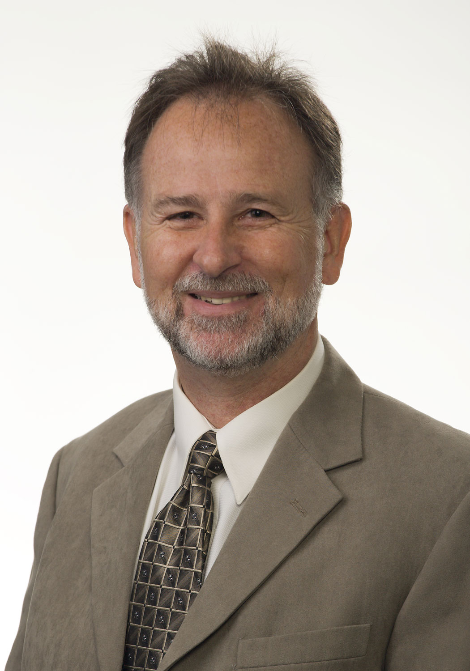

Chuck Nickerson

As Operational Excellence Subject Matter Expert for Life Cycle Engineering (LCE), Chuck Nickerson helps clients achieve their technical, financial and culture-based goals. Chuck works directly with client sites in the areas of Operational Excellence education, assessment and implementation. He has assisted organizations within various industries including Rayonier, Novelis and Cargill.

Prior to working with LCE, Chuck’s recent experience focused on project management of manufacturing and information systems initiatives including the implementation of a company-wide (global) ERP / MES project. He has a wealth of experience in the management of operations and maintenance and has held roles in both arenas while employed with Westbrook & South Portland.

Chuck’s leadership style balances a strong bottom-line focus with support, recognition and development of people. He has an excellent ability to partner with multiple disciplines to identify, organize and direct necessary resources to meet objectives through business re-engineering and change management. In addition to his role as Subject Matter Expert, Chuck also leads LCE’s Operational Excellence Community of Practice.
To learn more about Life Cycle Engineering, contact: 843.744.7110 | info@LCE.com | www.LCE.com

